HSPICE Homework #2

**Hw2.1**

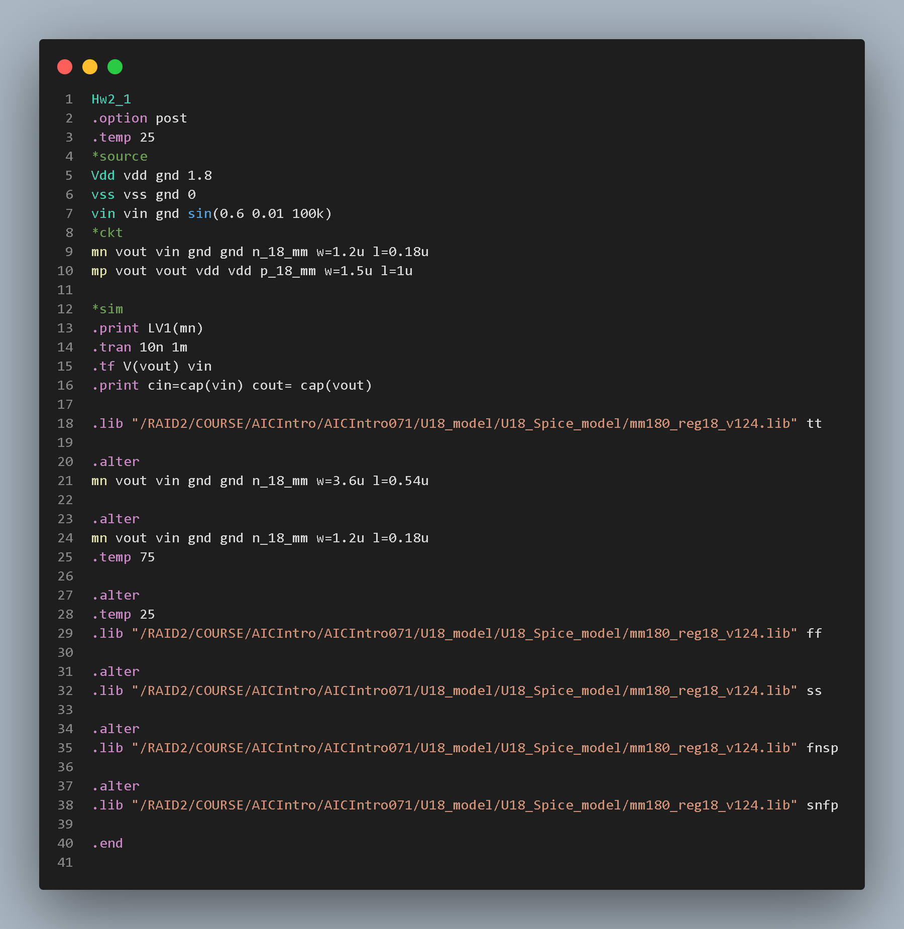

**The pictures below are all in the order as the chart.**

**Vout waveform:**

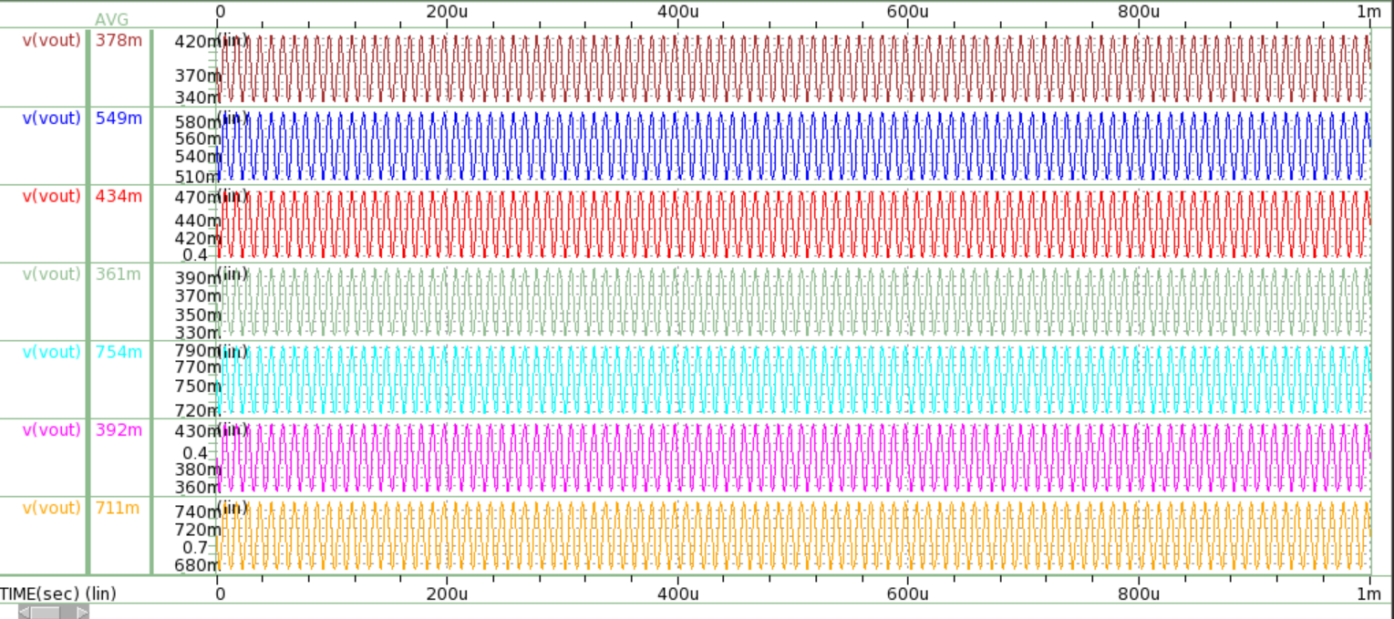

**Ids waveform:**

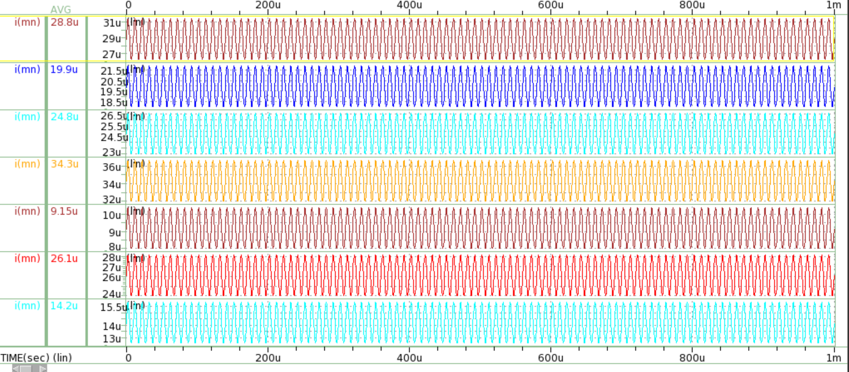

**Small signal:**

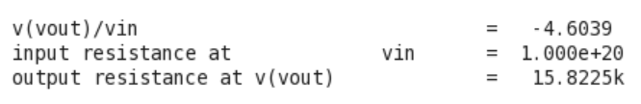

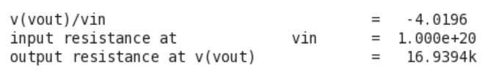

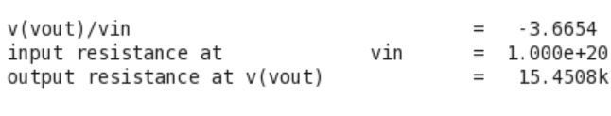

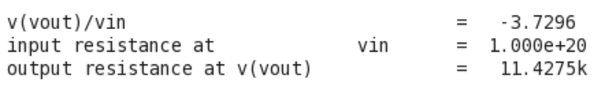

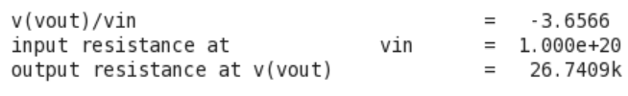

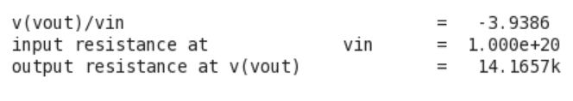

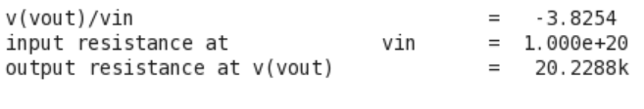

**Cin:**

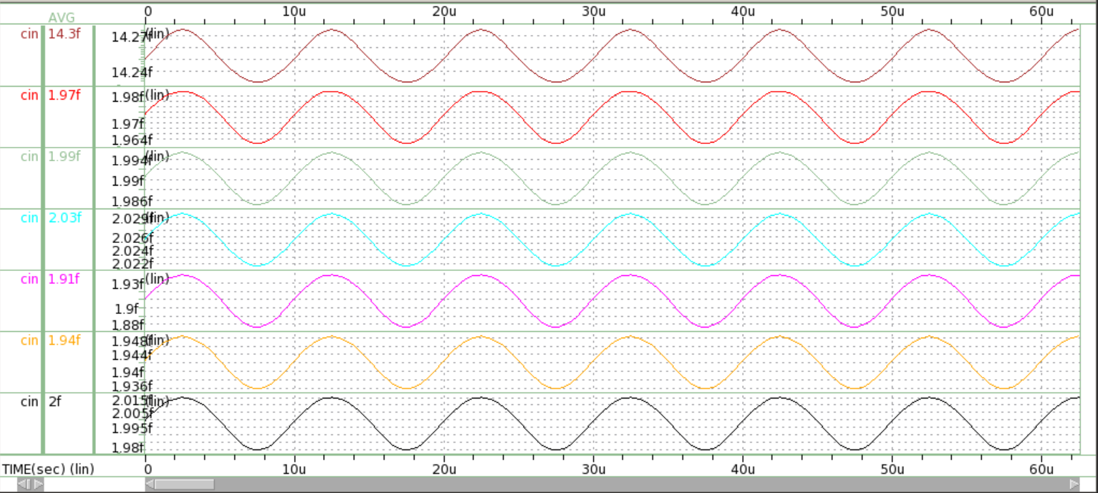

**Cout:**

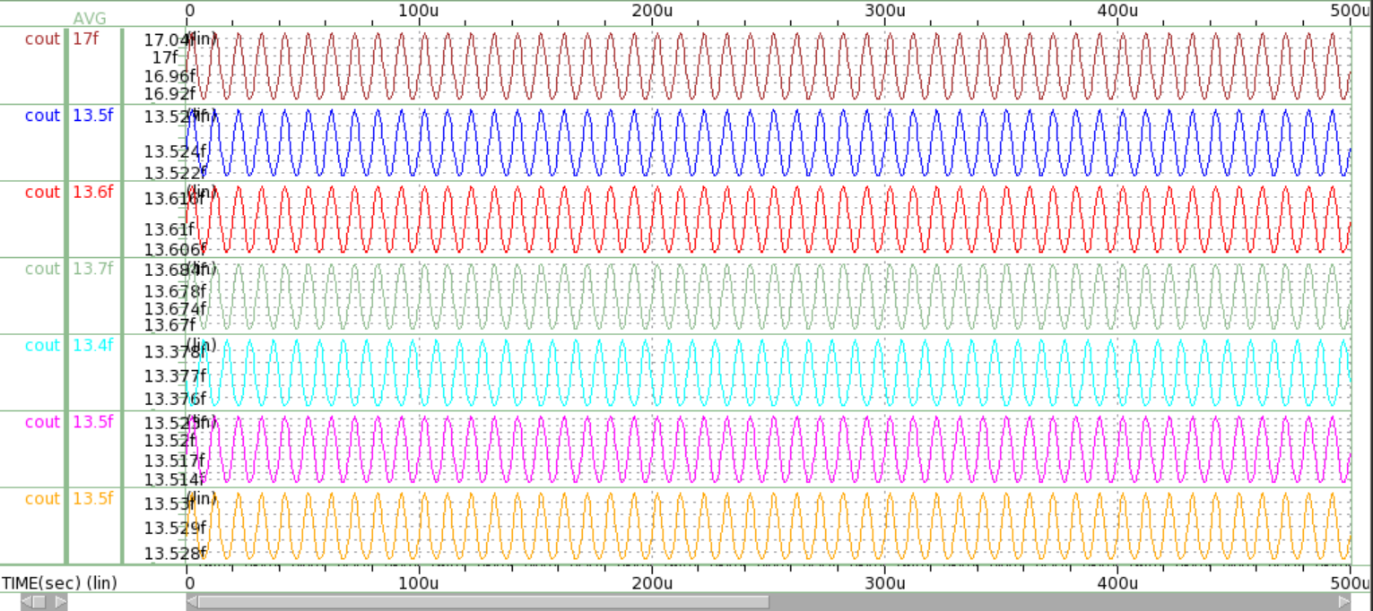

Table: NMOS common-source amplifier

|  |  |  |  |  |  |  |  |  |
| --- | --- | --- | --- | --- | --- | --- | --- | --- |
| **Corner** | **Temp**  **(°C)** | **Circuit** | **Vout**  **(V)** | **Ids**  **(mA)** | **DC gain**  **(V/V)** | **Rout**  **(Ω)** | **Cin**  **(F)** | **Cout**  **(F)** |
| TT | 25 | Fig. 2 | 378m | 0.0288 | -4.604 | 15.823k | 14.3f | 17f |
| TT | 25 | Fig. 1 | 549m | 0.0199 | -4.019 | 16.939k | 1.97f | 13.5f |
| TT | 75 | Fig. 1 | 434m | 0.0248 | -3.665 | 15.451k | 1.99f | 13.6f |
| FF | 25 | Fig. 1 | 361m | 0.0343 | -3.73 | 11.428k | 2.03f | 13.7f |
| SS | 25 | Fig. 1 | 754m | 0.00915 | -3.657 | 26.741k | 1.91f | 13.4f |
| FnSp | 25 | Fig. 1 | 392m | 0.0261 | -3.939 | 14.166k | 1.94f | 13.5f |
| SnFp | 25 | Fig. 1 | 711m | 0.0142 | -3.825 | 20.229k | 2f | 13.5f |

**Hw2.2**

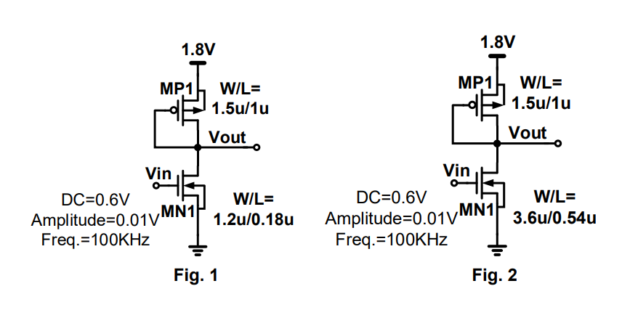

**Figure 1.W/L=1.2u/0.18u=6.6667**

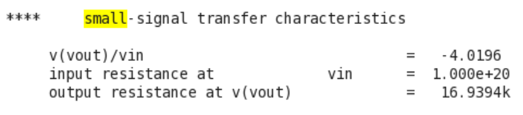

**Figure 2.W/L=3.6u/0.54u=6.6667**

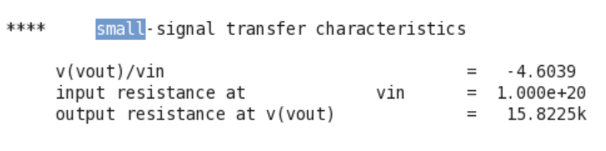

**Rout analysis:**

The picture above shows the output resistance of Figure1 is larger than Figure2. Some reasons determine this result. First, the Rout of both circuits is equal to //rop//ron.

And we know gmp is proportional to ID. Due to the velocity saturation on short channel devices, ID will prematurely saturate, which causes ID much smaller than expected. Thus, the smaller gmp and ID are, the larger the Rout will be.

Also, the ron is equal to . Thus, As ID decreases, ron will also get larger. What’s more, λ is proportional to , which will cause **a larger Rout when the Length is small**.

**Gain analysis:**

The two figures show the gain of figure2 is larger than the figure1. Recall that we just mention the velocity saturation above, which will let ID be smaller on the short-channel devices. Once ID gets smaller, gmn will also get smaller. This will **result in a smaller gain**.

**Hw2.3**

**Figure1 temp25 (ID=19.9uA)**





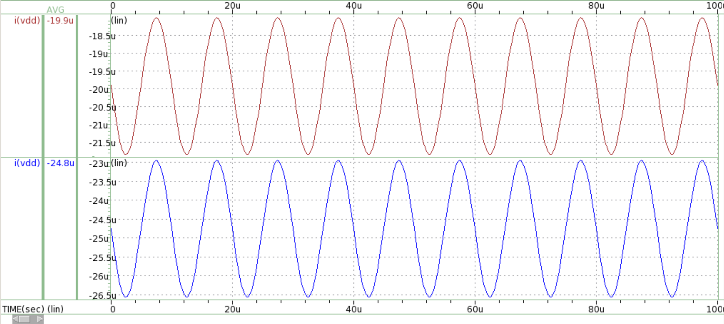

**Figure1 temp 75 (ID=24.8uA)**





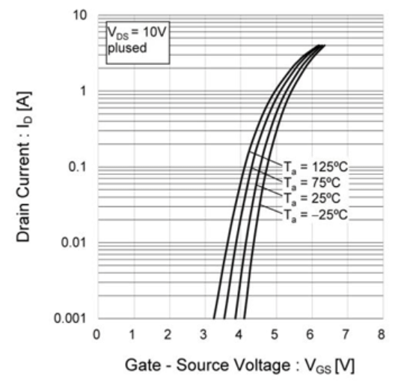 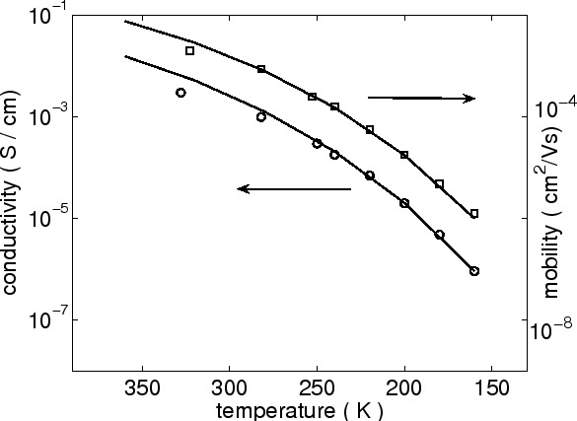

**Rout analysis:**

The left picture shows that if VGS is a constant, ID will increase as temperature increases. The reason is that ID=, and the right picture shows that as temperature increases, Un will increase too. Thus, we can know that if temperature increases, ID will increase.

We know that ro=1/gds. The result above shows that gds increase when the temperature increases from 25 degrees to 75 degrees, which implies ro decrease.

It is known that Rout=//rop//ron, and ron and rop are equal to . Thus, as ID increase, **Rout will get smaller**. This is totally the same as the result in hspice.

**Gain analysis:**

It is proved that a higher temperature results in a lower Rout in this circuit. And it is known that the gain formula is Av=-gmn*Rout. From the result above, it shows that gm didn’t change obviously due to the cancelation of Vth and Un. Therefore, if Rout gets smaller, **Av gain will also get smaller**. This deduction exactly accords with the Hspice result.